Amelia’s Flower Barn: Observations - concluding that the permission was incorrectly given.

22/01536/FUL | Proposed agricultural building | Land At Ngr 289664 71750 Combeinteignhead Devon

David Halpin FRCS May 24th 2024

I was told of this two storey steel structure as it was being erected at the top of the Zachery lane early in 2023. Several residents of Combe were angry that there had been no posted notice and by its size compared with its claimed function.

I have been concerned for many years about unjustified and inappropriate buildings or conversions to residential use which have harmed the beautiful landscapes of the Haccombe-with-Combe Parish, and often the amenities.

The planning file is large. I am grateful for the help given me by the Enforcement Officer Mr Peter ….. for the link to it so that I can study it for a second time.

Images

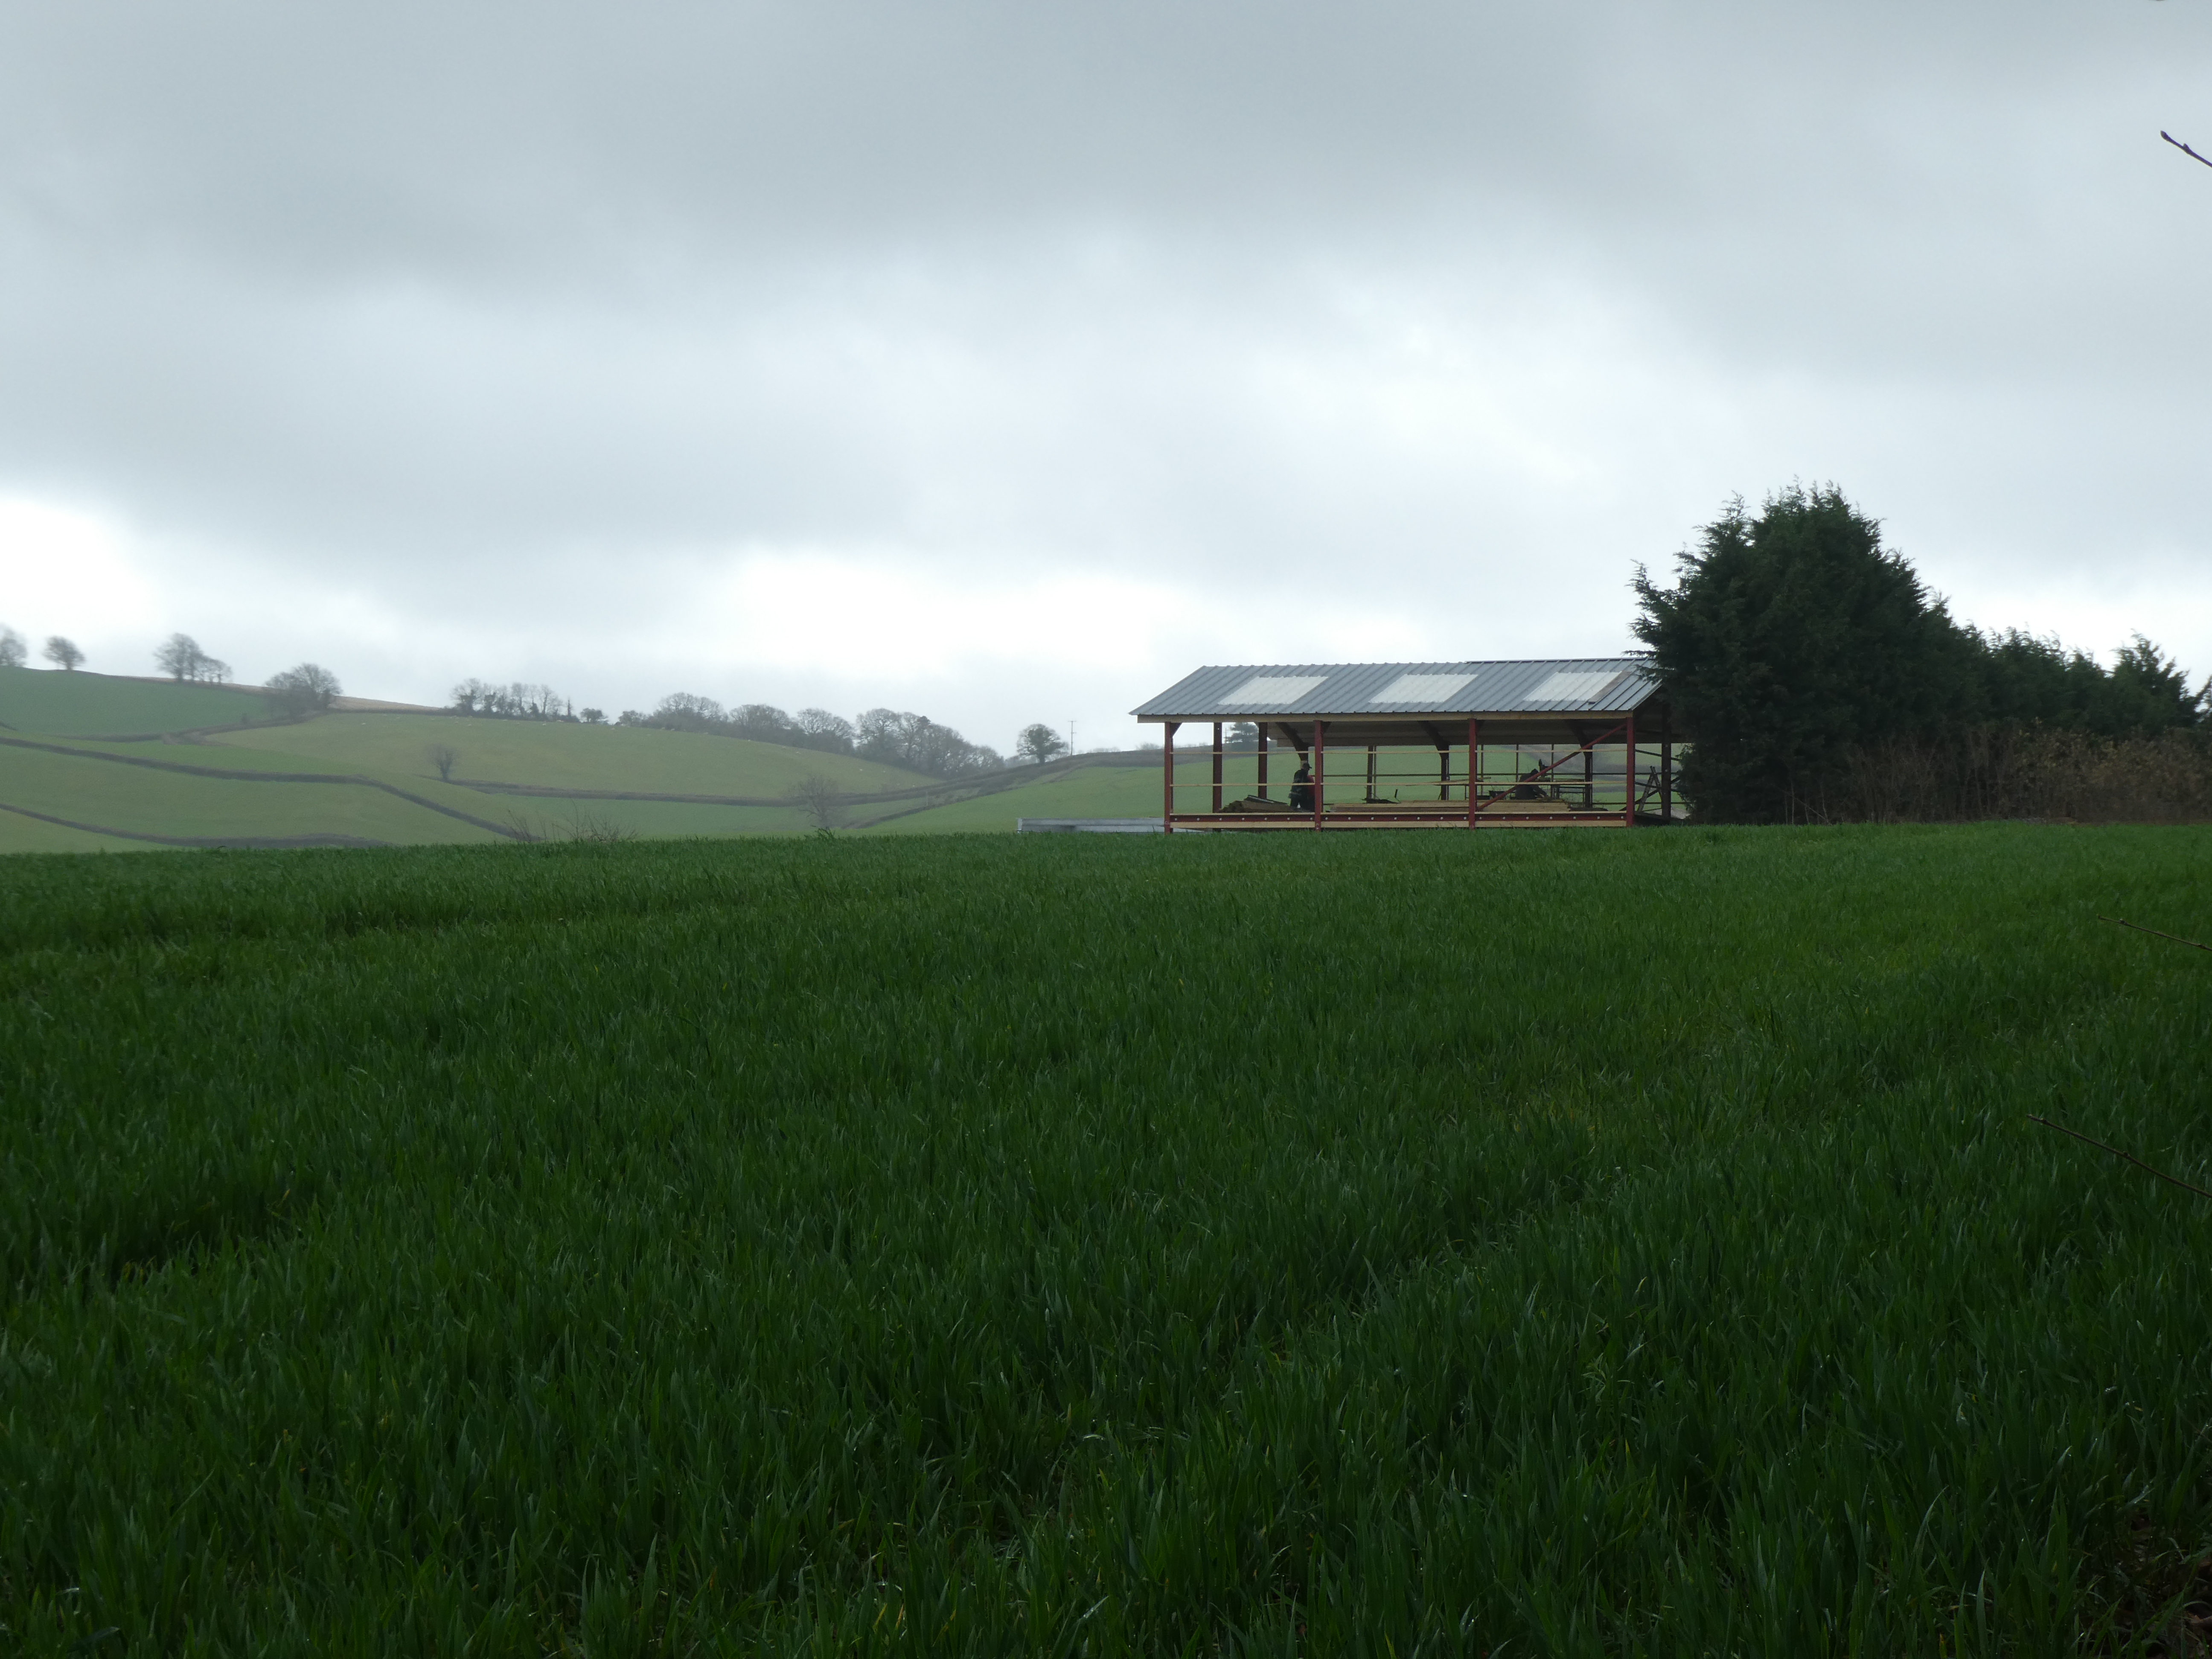
During erection - as seen from the public footpath leading over Pathfields. The ‘beautiful Brecchia hills’ are seen in the distance. 23-03-2023

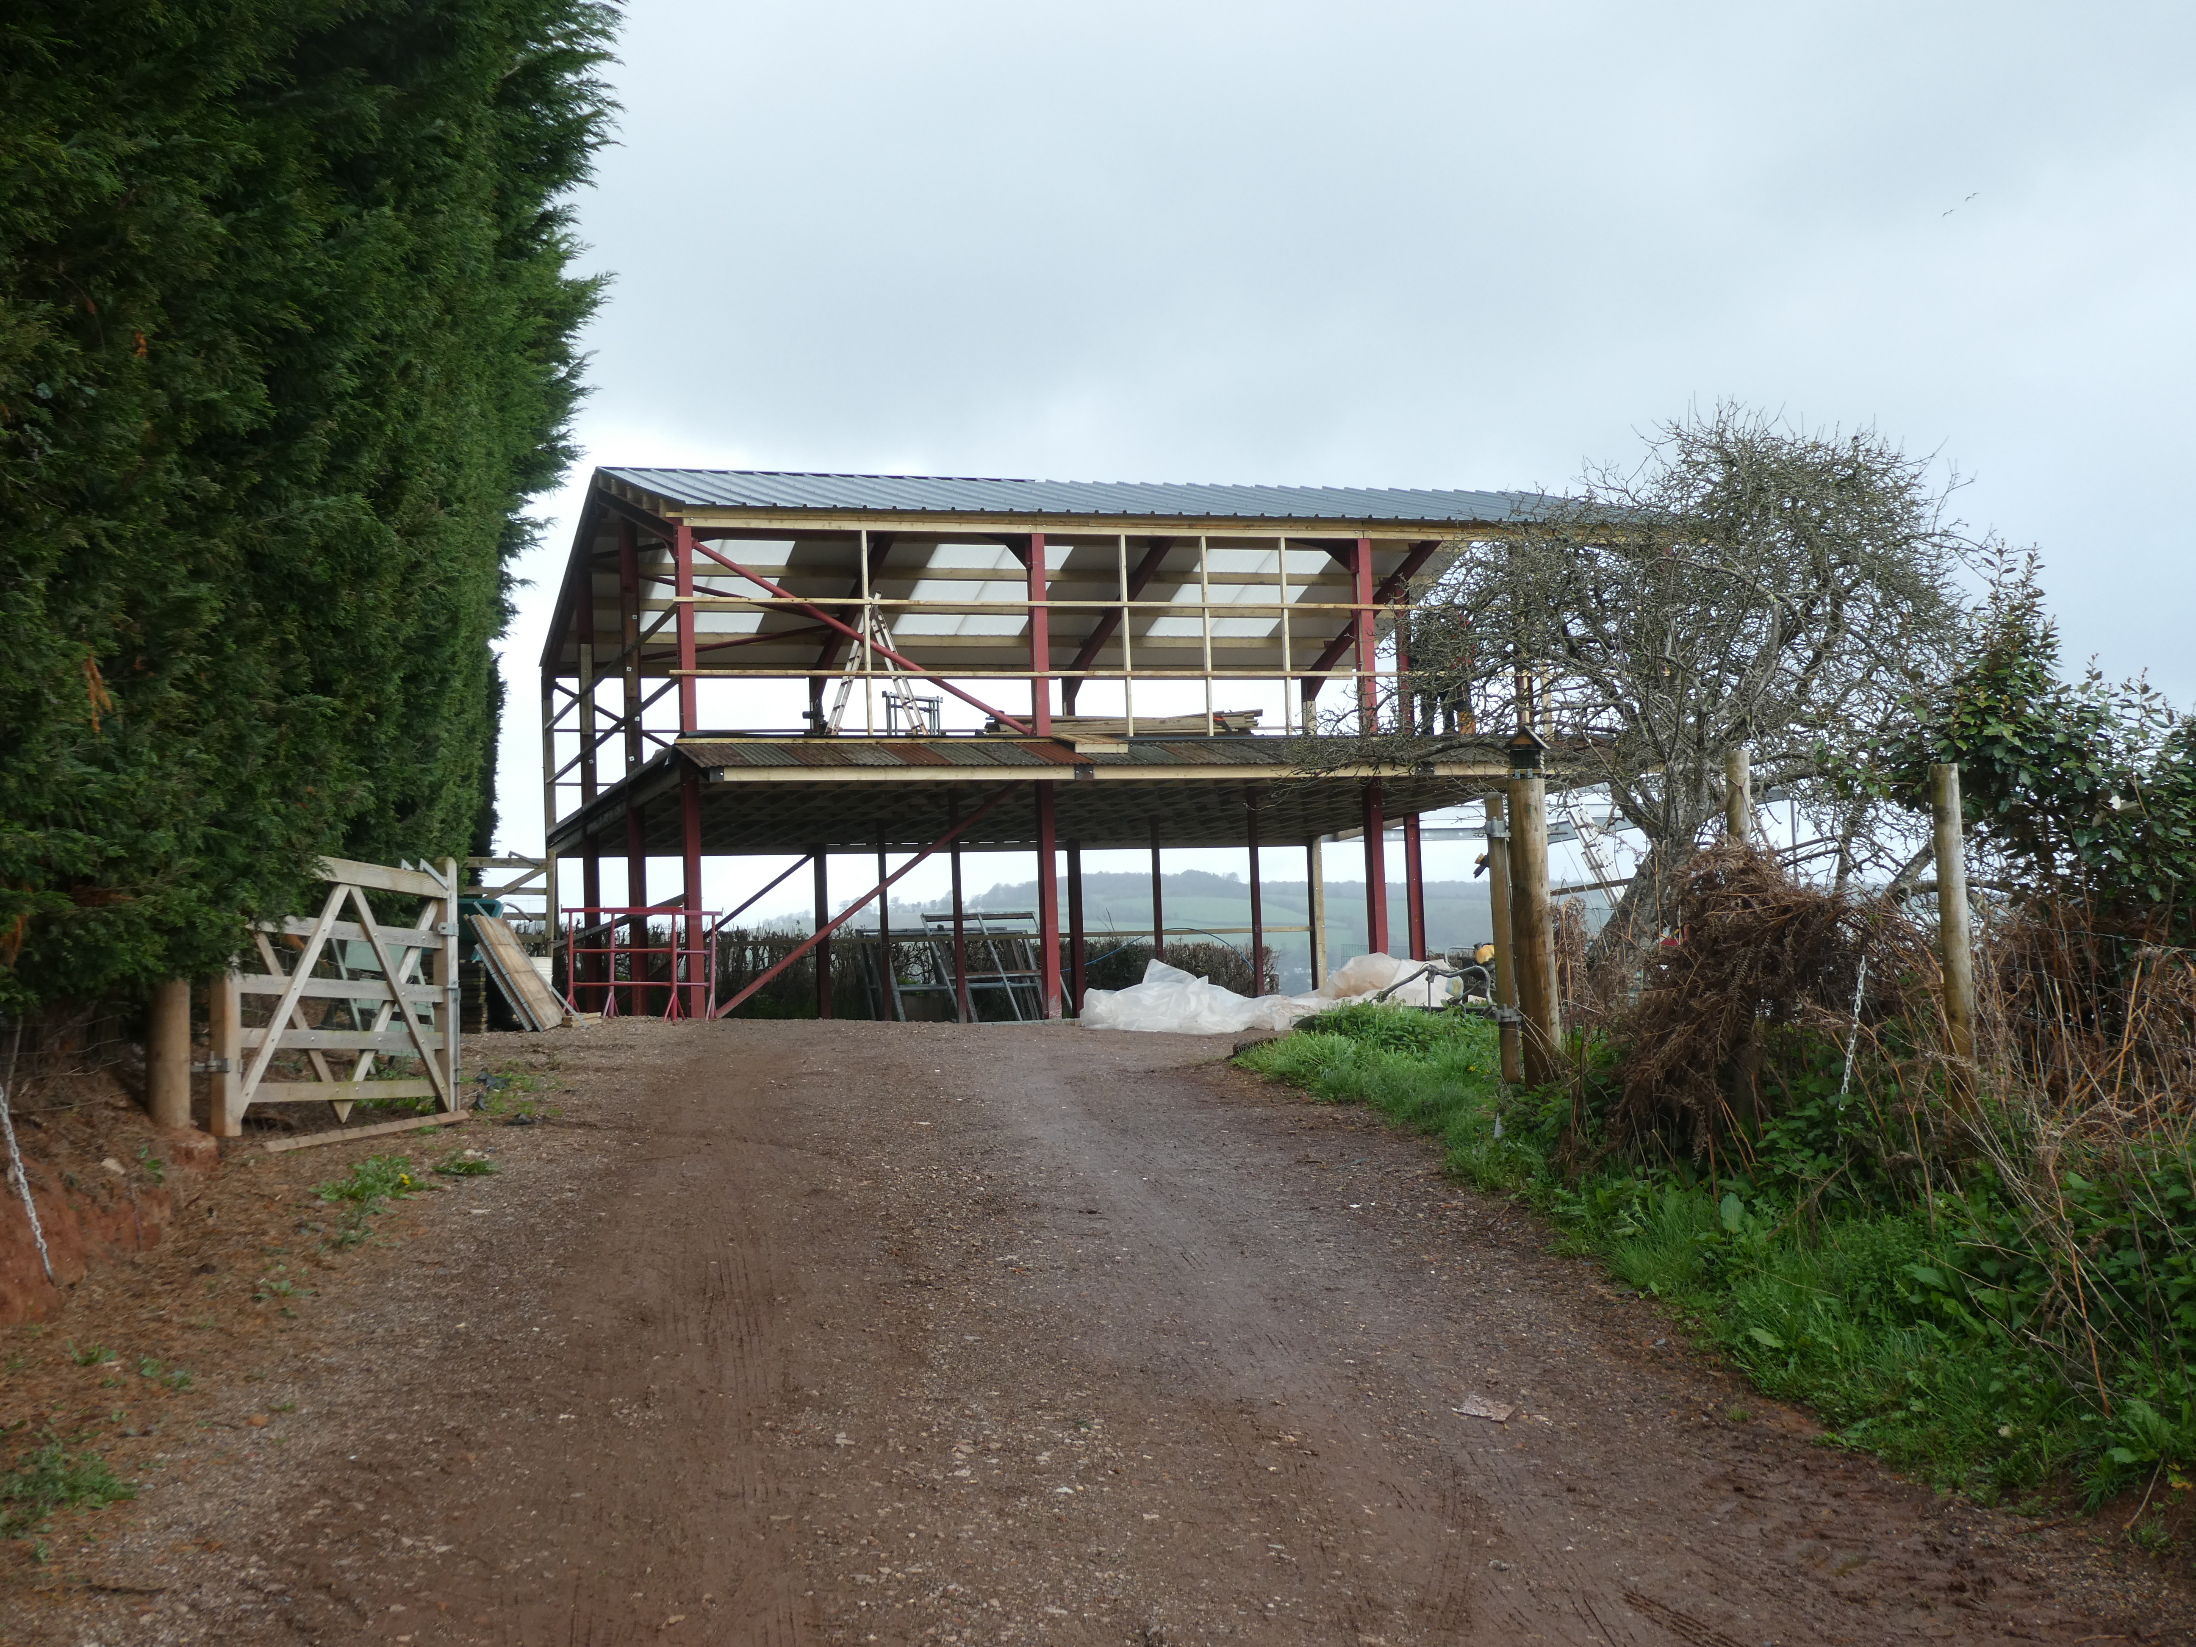
The massive steel structure as seen from Zachery Lane 23-03-2023

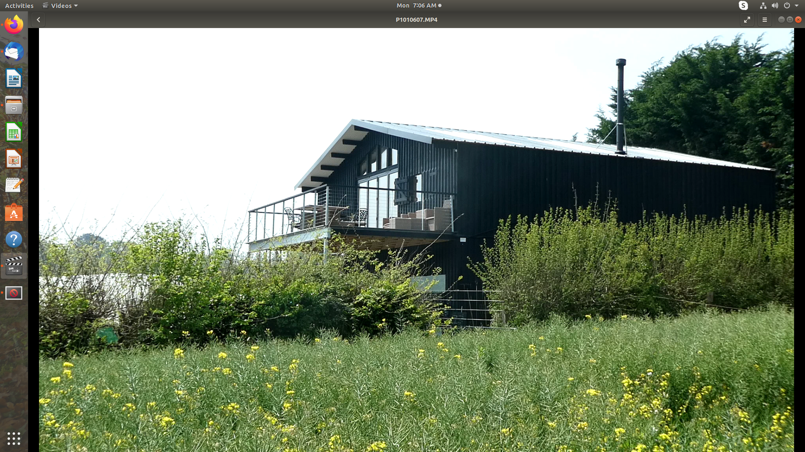
From Pathfields in May 2024. The addition of a large verandah to be noted with quote ‘stunning views over the estuary’.
Insert image of completed ‘flower barn’ as seen from the south – Zachery Lane

Deceit

1. ‘Design and Access Statement’ 9-08-2022

Images and describing text show an active and attactive flower farm, with asoociated activities – attending shows etc.

Quotes – selected, part in irony -

The business currently includes 2 acres of land with a further 3 acres to be planted shortly. The current arrangement includes 8 large polytunnels and 3 greenhouses with approximate growth of 450,000 stems per year of British heirloom flowers and foliage.

The building also includes a store for feed and machinery/vehicle associated with the business.

The site is located outside any defined settlement limits (sic) therefore in accordance with
provisions of Policy S22 is considered as development in the open countryside. The Policy sets
out that proposals for the purposes of horticulture are considered to be acceptable in
principle in countryside locations. In this instance horticulture is considered to be a type of
agriculture and the above details of the business are sufficient to provide justification of the
development. The site is also located within the Undeveloped Coast designation of the Local
Plan where Policy EN2 seeks to protect, maintain and enhance the distinctive landscape of
the undeveloped coast. Development which would have a detrimental effect on the
character of the undeveloped coast and the estuaries will not be permitted and new
development will be regarded as inappropriate expect (sic) where it has regard to the Shoreline
Management Plan and is require (sic) for the purposes of agriculture. On that basis the principle of
the proposal is considered acceptable (DSH – by whom?) in this location subject to the design being acceptable
for the location.
In response to the pre-application enquiry to Teignbridge District Council, it was concluded:
‘the proposal for the building for the purposes of the horticultural business is considered
acceptable and justified. Further details should be demonstrated in respect of the workshop use
ensuring that the use remains ancillary to the main horticultural use. Subject to the suggestions
made in the above advice it is likely that the proposal will receive support at the full application
stage.’
Site Levels
In order to reduce the visual impact of the building it is proposed to lower the ground level in
the North West corner by 1.2m reducing its visibility from the other side of the river. Due to the
topography and existing mature landscaping, views of the building from close by are more
restricted.

Scale
The size and scale of the proposed building has been considered to give all the elements
essential for the running of the business and no more. The concept of a 2 storey structure
allows for a lesser footprint and less intrusion into the landscape

(DSH – Scale. There is no scale so dimensions are indeterminate. The two plan views of ground floor and first floor look smaller ie less wide as seen from the road side.)

Layout
The proposed building has been laid out to work functionally with the needs of the business
whilst sitting comfortably within the the aesthetics the scheme seeks to achieve.
On the ground floor, there is a central parking area which will double up as a useful working
space in inclement weather. Leading from this there is a feed store, general store, refrigerated
flower room and tractor store. At first floor level there is a multi-use space providing a hay loft
and workshop.

Siting

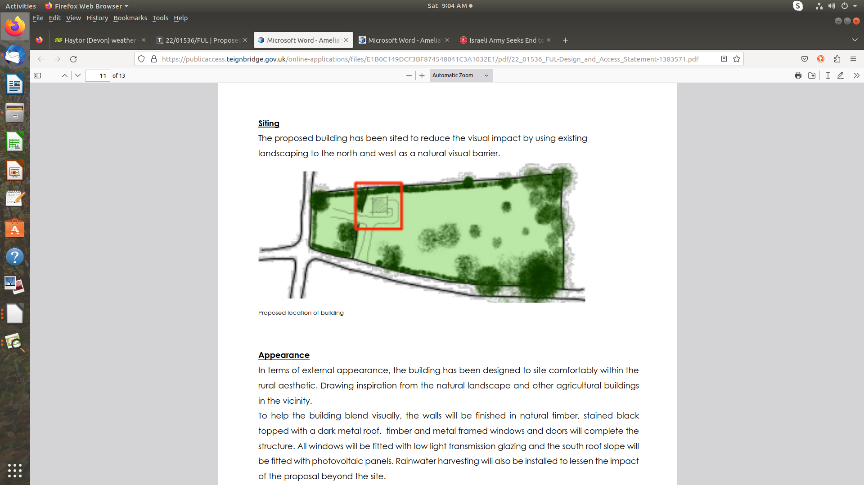
The proposed building has been sited to reduce the visual impact by using existing
landscaping to the north and west as a natural visual barrier. Proposed location of building

Appearance
In terms of external appearance, the building has been designed to site comfortably within the
rural aesthetic. Drawing inspiration from the natural landscape and other agricultural buildings
in the vicinity.
To help the building blend visually, the walls will be finished in natural timber, stained black
topped with a dark metal roof. timber and metal framed windows and doors will complete the
structure. All windows will be fitted with low light transmission glazing and the south roof slope will
be fitted with photovoltaic panels. Rainwater harvesting will also be installed to lessen the impact
of the proposal beyond the site.

Landscape
The integration of the proposed building into the existing landscape is vital to the success of the
project as a whole. From initial concept to finalised design, the client has been keen to work
with the existing topography and vegetation this is demonstrated by leaving the ancient apple
trees lying on their sides in place to restrict the visual impact of the structure. (DSH – site a former orchard.)As part of the
scheme:
• The client intends to reduce the ground level by 1.2 meters to reduce visual impact.
• The west elevation is fully hidden by 40ft leylandii trees
• The north elevation is 50% hidden by a Devon hedge row
• There will be a planting scheme installed on the south elevation containing perennial (?)
foliage’s; examples being viburnum – (DSH ? ‘Wayfaring tree - deciduous)
• Further to pre-planning recommendations, the glazing element on the east elevation (DSH – and the verandah ?) has
been reduced and set back to minimise any glare and anti-glazing will also be used
• The building will be clad on all sides with standard treated timber
• The roof will be dark corrugated metal

Conclusion
The proposal has evolved due to a recognised horticultural need of a growing rural business.
The client has sort the advice of the Local Planning Authority through the pre-application
process and has taken into account the recommendations made (DSH – including the need for excavation.) The scheme has progressed in a manner mindful of the existing landscape, visual impact and ecology offering a building
which fulfils a necessity whilst restricting wider harm.

